


MS Dynamics GP – QSSI POWERHOUSE WMS Integration
Reference Document

Table of Contents
Version Information 3
Integration Setup 4
Creating Tables 4
Powerhouse Integration Setup Window 4
Powerhouse Location Mapping Window 5
Sales Order Integration 7
Sending a GP sales order to Powerhouse 7
Automated Process 7
Manual Process 7
GP Sales Order Fulfillment Process 10
Inventory Integration 11
Sending an item to Powerhouse 11
Manual Process 11
Automated Process 12
Receiving Integration 13
Sending GP Receiving Data (Container Information) 13
Viewing Integrated Data 15
Purchase Order Integration 17
Sending GP Purchase Order Data 17
Inquiry Windows 19
Sales Integration 19
PO Integration 20
About Window 21
Version Information 21
File Repository 21
Data Dictionary 22
BSP – Powerhouse Data Mapping 22
Sales Order 22
Inventory 24
Receipt 24
Purchase Order 25
Receiving (Powerhouse to GP) 27
Inventory Transfer (Powerhouse to GP) 27
BSP Tables 29
Troubleshooting 33

Version Information
Version | Resource | Date | Remarks
1.0 | Ric Paras | Apr 1, 2020 | Created Document
1.1 | Ric Paras | May 9, 2020 | Updated Screenshots, Added Processing Steps, Added more table definitions
1.2 | Ric Paras | May 13, 2020 | Added Inventory Item sending and table mapping
1.3 | Ric Paras | May 26, 2020 | Updated Receiving Maintenance. Added PO Integration. Added About Window
1.4 | Ric Paras | June 5, 2020 | Added Auto Sync of Items
1.5 | Ric Paras | August 13, 2020 | Updated PO Integration. Updated Setup. Added Inquiry Windows. Updated Mapping
1.6 | Ric Paras | September 15, 2020 | Added File Repository Section
1.7 | Ric Paras | October 12, 2020 | Added Troubleshooting section

Integration Setup

Creating Tables
The first thing to do is to create the BSP tables. Users can do this by navigating to MS Dynamics > Tools > Setup > System > BSP Create Tables. Click on the Create Tables button. The tables created are referenced in the Data Dictionary section.

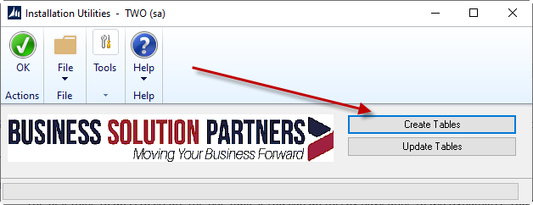
Installation Utilities window

Alternately, when updating existing tables, just press the Update Tables button.

Powerhouse Integration Setup Window
To setup the values that would be used by the integration, users would need to fill up the Powerhouse Integration window. Users can access this window by navigating to MS Dynamics > Tools > Setup > Company > Powerhouse Integration Setup.
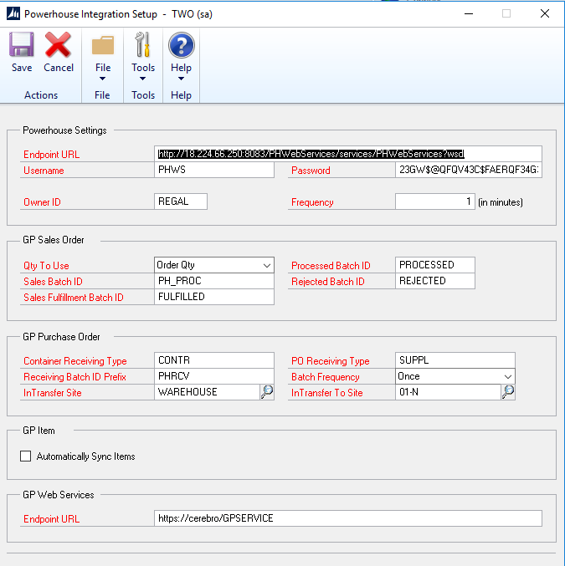
Powerhouse Integration Setup window
Window Field | Description
Endpoint URL | URL to Powerhouse Web Service
Username | Powerhouse User Name
Password | Powerhouse Password
Owner ID | Powerhouse Owner
Frequency (In Minutes) | Interval on when the service that pulls records from Powerhouse is to run
Qty To Use | 1 = Order Qty, 2 = Allocated Qty. The qty in the sales order to send to Powerhouse for picking
Sales Batch ID | The Sales Batch ID that will contain the sales orders that would be sent automatically by the automated service to Powerhouse.
Sales Fulfillment Batch ID | The Sales Batch ID that will contain the fulfilled orders would be transferred to by the automated service once they get fulfilled in Powerhouse.
Processed Batch ID | The Sales Batch ID that will contain the sales orders that were successfully sent to Powerhouse.
Rejected Batch ID | The Sales Batch ID that will contain the sales orders that encountered errors when integrating to Powerhouse.
Container Receiving Type | The Powerhouse Receipt Type for Containers
PO Receiving Type | The Powerhouse Receipt Type for regular Purchase Orders in GP
Receiving Batch ID Prefix | The prefix id to use for the receiving batch numbers as well as the inventory transfers
Batch Frequency | The identifier on how the receiving batches as well as the inventory transfer batches would be named. The formula would be “Receiving Batch ID Prefix” + Batch Frequency value (e.g. PHRCV-10AM)
In Transfer Site | The origin GP Site for the Inventory Transfer (Container Receipts)
In Transfer To Site | The destination GP Site for the Inventory Transfer (Container Receipts)
Automatically Sync Items | This option is used to check if items that have been added or updated (with the exception of delete) should be synchronized with Powerhouse

Powerhouse Location Mapping Window
Dynamics GP Locations need to be mapped to Powerhouse Warehouse IDs. To setup the mappings, navigate to MS Dynamics > Tools > Setup > Inventory > Powerhouse Location Mapping.
Choose the Dynamics GP Location codes along with their appropriate Warehouse IDs.
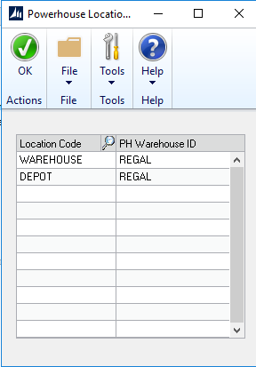
Powerhouse Location Mapping window

Sales Order Integration

Sending a GP sales order to Powerhouse

Automated Process
- There is a background process in the GPWEB.regal-arts.local server that would automatically send GP sales orders to Powerhouse as long as their batch is set to the Sales Batch ID in the Powerhouse Integration Setup window.

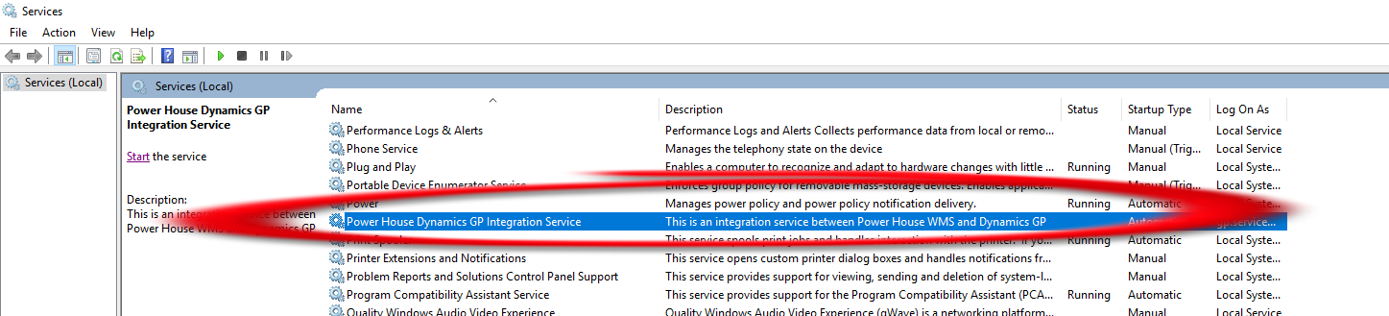
Powerhouse Dynamics GP Integration Service

- This service runs at certain time intervals (check the Frequency value in the Powerhouse Integration Setup window) to check if there are sales orders that are included in the Sales Batch ID.
- Sales orders that were processed successfully would be moved to the Processed Batch ID and those that failed would be sent to the Rejected Batch ID (see Powerhouse Integration Setup)
* Note: Make sure that the Status of the service is Running. Also make sure that the GP Services’ status are set to Running.

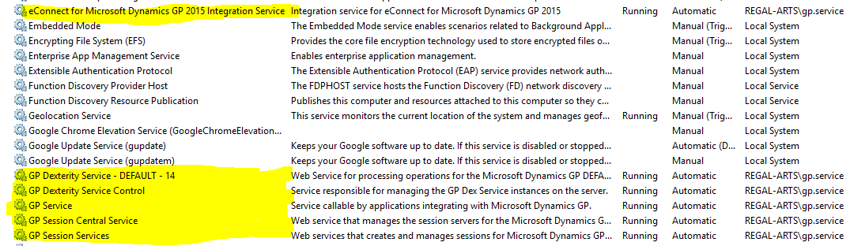

Manual Process
- To send a GP sales order to Powerhouse, users would need to create a new Sales Order Transaction in GP or open an existing record.
- Once users have filled out the required fields, they should click on the Additional menu and then select Powerhouse.

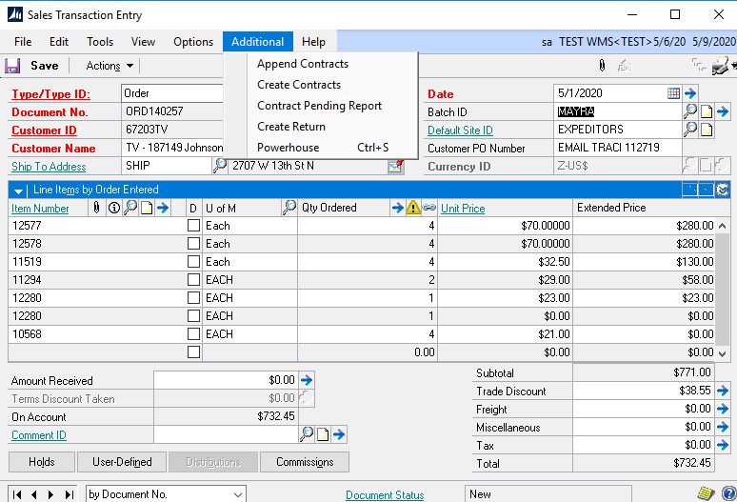
Powerhouse option in the Additional Menu
- The Powerhouse SO Integration window would show up.

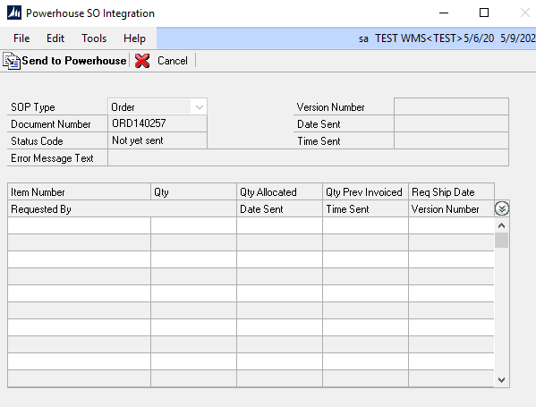
Powerhouse SO Integration window

- Press the Sent to Powerhouse button to being the process of sending the sales order to powerhouse.

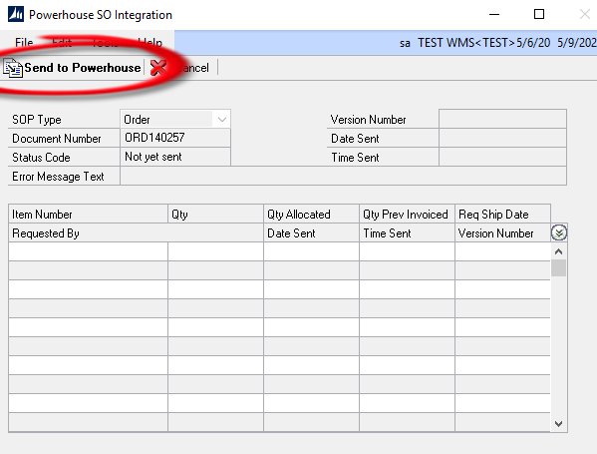
Send to Powerhouse button

- If prompted if sure to send the record to Powerhouse, press the Yes button.

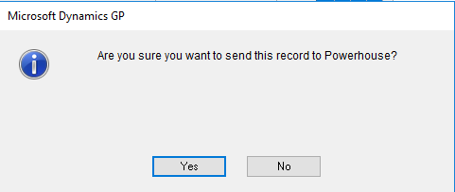
Confirmation prompt message

- If the sales order was successfully sent to Powerhouse, users will be alerted with a success message. Press the OK button to close.

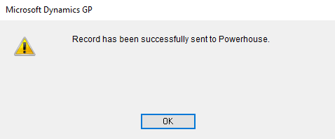
Success message

- The order status information as well as the items that were sent would be displayed in the window.

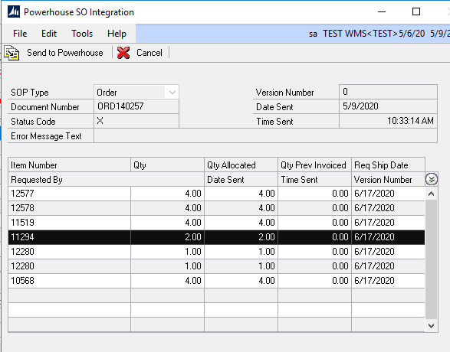
Order information

- Press the Cancel button to close the window and go back to the Sales Order Entry window.

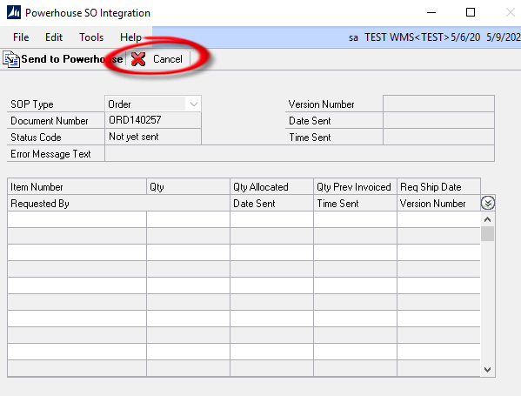
The Cancel button

- If the sales order was sent to Powerhouse successfully, the Sales Order batch ID will be replaced with the Processed Batch ID that was setup in the Powerhouse Integration Setup window.

GP Sales Order Fulfillment Process
For every shipment that has been picked and packed in Powerhouse, an automated process will read these shipments and then fulfill the sales orders in GP. The fulfilled quantities would be updated for each sales order and then moved to the Sales Fulfillment Batch ID that was setup in the Powerhouse Integration Setup Window.

Inventory Integration

Sending an item to Powerhouse

Manual Process
- Users can send inventory items from GP to Powerhouse through the Item Maintenance window.
- Open the Item Maintenance window (Inventory > Cards > Item) and then select (or create) the item record.
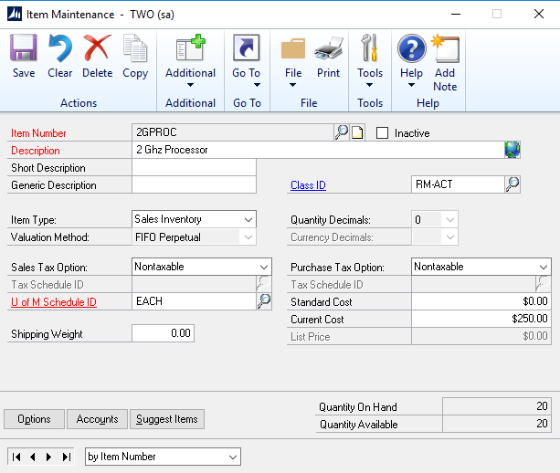
Item Maintenance window

- Next, click on the Additional button and then select Powerhouse.
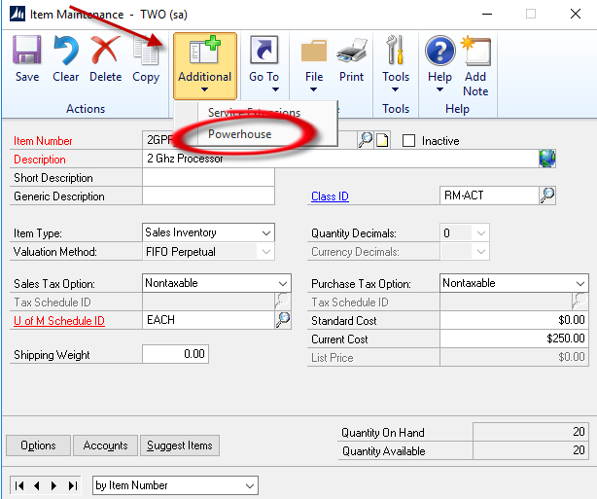
Powerhouse option in the Additional menu

- Once the Powerhouse Item Integration window has opened, click on the Send to Powerhouse button to begin the integration process.
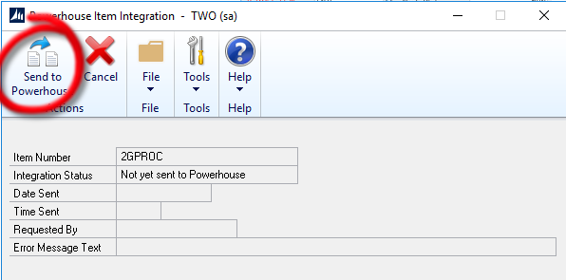
Send to Powerhouse button in the Powerhouse Item Integration window.

- If the integration was successful, an alert will prompt the user for the result.
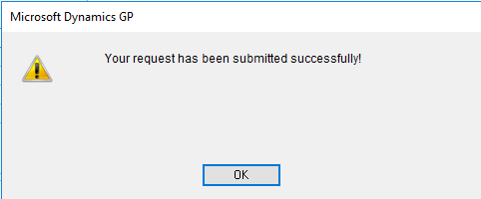
The prompt when the record has been integrated.

Automated Process
- There is a background process that would automatically send GP Items to Powerhouse as long as the option to Automatically Sync Items is checked in the Powerhouse Integration Setup window.

Powerhouse Dynamics GP Integration Service

- This service runs at certain time intervals (check the Frequency value in the Powerhouse Integration Setup window) to check if there are items to process.
* Note: Make sure that the Status of the service is Running.

Receiving Integration

Sending GP Receiving Data (Container Information)
- GP Receiving records can be integrated to Powerhouse by going to the Powerhouse Receiving Integration window (Transactions > Purchasing > Powerhouse Receiving Integration)

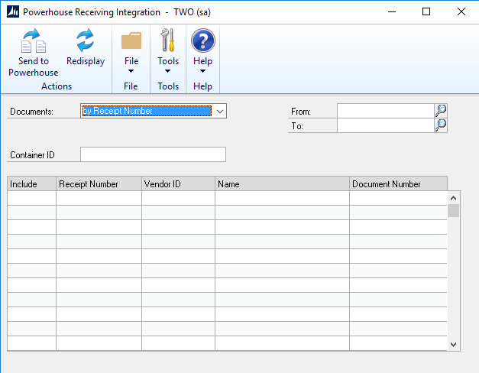
Powerhouse Receiving window.
- There are 2 options on how users can retrieve posted receipts: by Receipt Number or by Document Date. Choose either one and then select the starting receipt number/document date and the ending receipt number/document date.
- After selecting the filters, click on the Redisplay button.

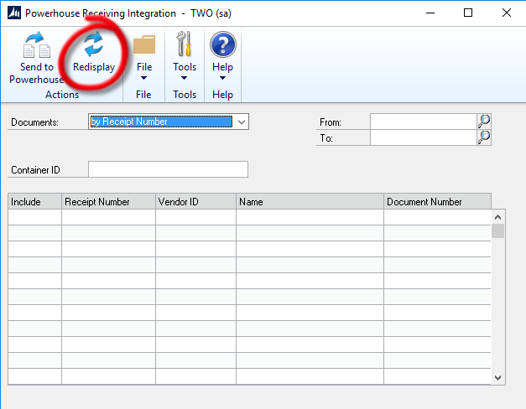
The Redisplay button.
- Once clicked, the window will display all the posted receiving records that have NOT yet been sent to Powerhouse.
- Users can select the receiving records to include by ticking the Include checkbox.

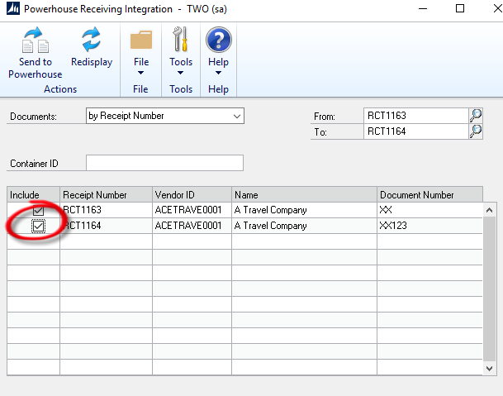
The “Include” checkbox
- After selecting all the receipts to include, enter the Container ID and then press the Send to Powerhouse button.

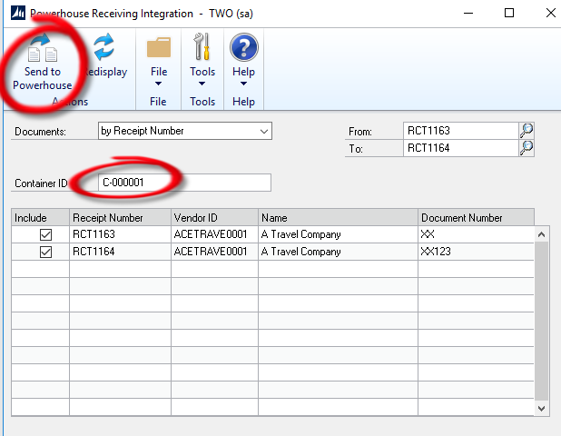
Container ID field and the Send to Powerhouse button
- Once users click on the Send to Powerhouse button, they will be prompted on whether they would want to send the container record to Powerhouse. Press the Yes button to continue.

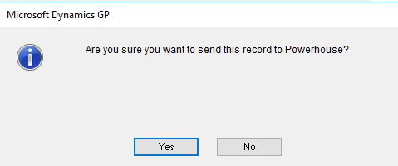
The confirmation prompt.
- A notification will be shown after the integration to show whether it was successful or if there was an error that was encountered during integration.

Viewing Integrated Data
- Users can view all the Container records that have been integrated to Powerhouse through the Powerhouse Receiving Integration Maintenance window (Cards > Purchasing > Powerhouse Receiving Integration Maintenance).
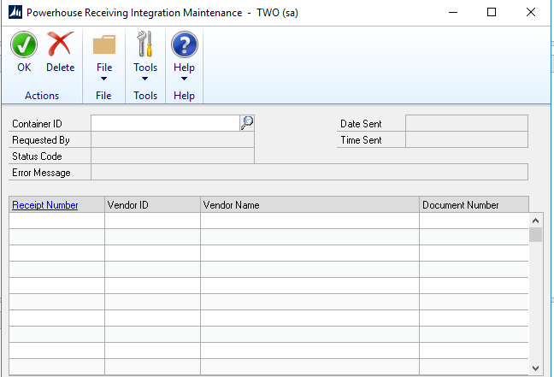
Powerhouse Receiving Integration Maintenance window
- Users can select the Container ID by typing it in or clicking on the Lookup button to show the available Container Records.
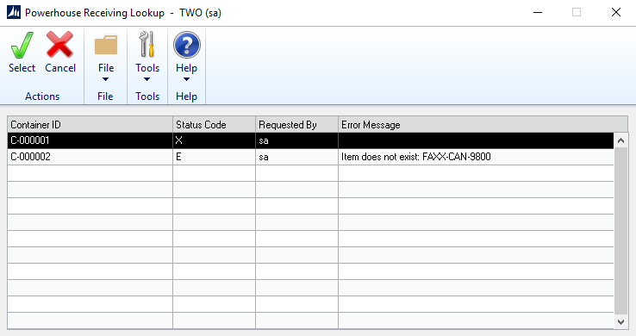
Powerhouse Receiving Container Lookup window
- Once the record has loaded, users can view the details and status of the integrated record. The receipt number along with the vendor details can be seen. Users can also zoom to the selected receipt number by clicking on the Receipt Number link.
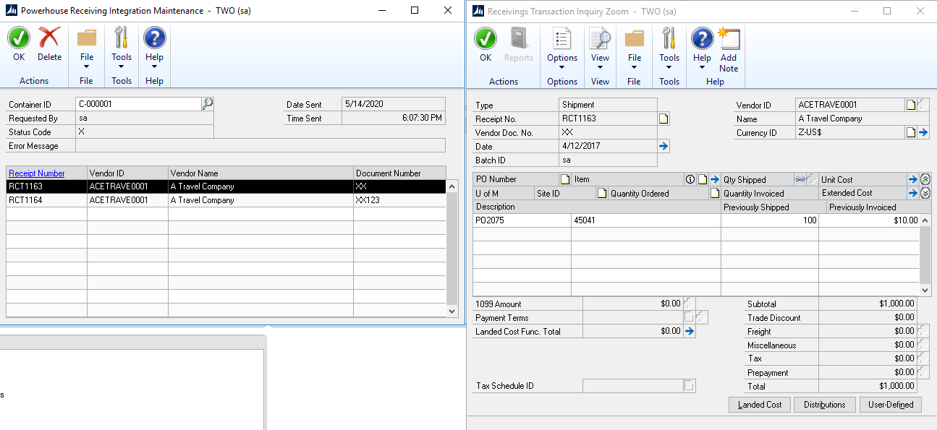
Container record details and the “zoomed” receipt record.
- A status code of “X” means that the container record has integrated successfully to Powerhouse, while a status of “E” means there was an error during the integration process.
- Users are allowed to delete records and can achieve this by clicking on the Delete button.

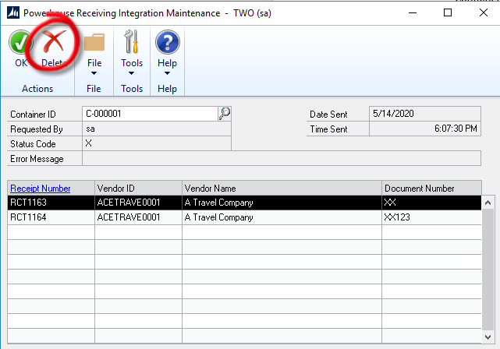
The Delete button
- Once the Delete button has been clicked, users will be prompted if they are sure to delete. Click on the Yes button to continue (Note: Deleting the container record in GP will also delete the record in Powerhouse).
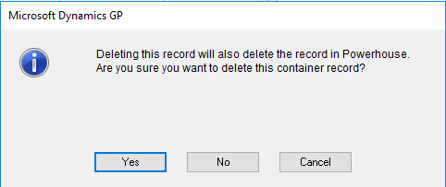
The confirmation prompt.

Purchase Order Integration

Sending GP Purchase Order Data
- Users can send Purchase Orders from GP to Powerhouse through the Purchase Order Entry window.
- These records would also be created as Receipts in Powerhouse.
- Open the Purchase Order Entry window (Purchasing > Transactions > Purchase Order Entry) and then select (or create) the Purchase Order record.
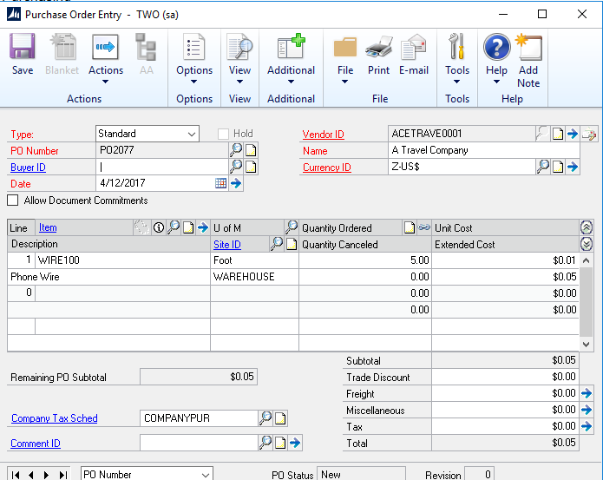
Purchase Order Entry window

- Next, click on the Additional button and then select Powerhouse.
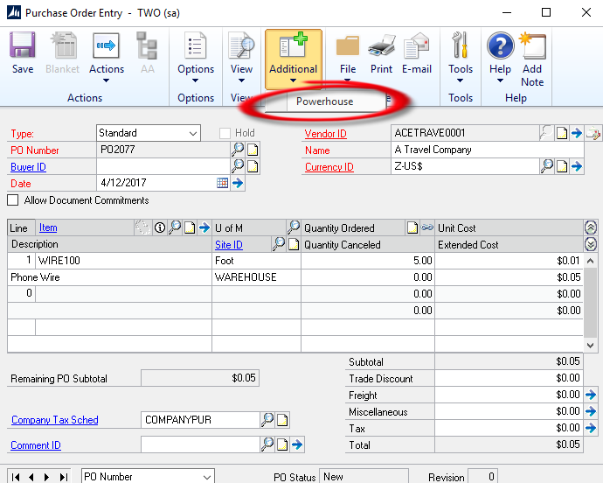
Powerhouse option in the Additional menu

- Once the Powerhouse Purchase Order Integration window has opened, click on the Send to Powerhouse button to begin the integration process.
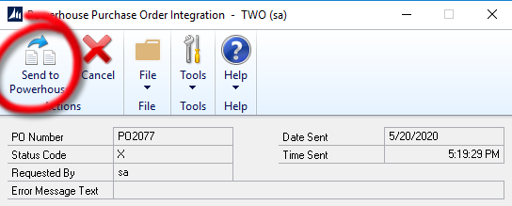
Send to Powerhouse button in the Powerhouse Item Integration window.

- If the integration was successful, an alert will prompt the user for the result.
The prompt when the record has been integrated.

Inquiry Windows

Sales Integration

Powerhouse SO Integration
Sales Transaction Inquiry Zoom > Additional > Powerhouse
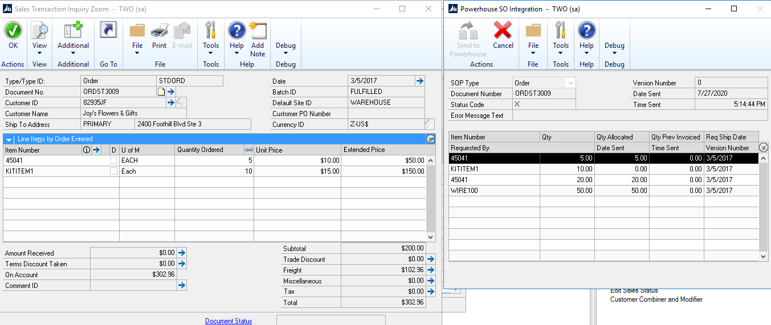
The Powerhouse SO Integration Window

Powerhouse SOP Transfer Integration Inquiry
Inquiry > Sales > Powerhouse SOP Transfer Integration Inquiry
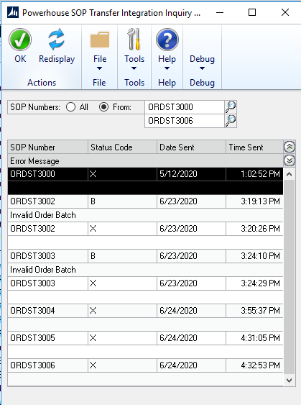
The Powerhouse SOP Transfer Integration Inquiry Window

PO Integration

Powerhouse PO Integration
Purchase Order Inquiry Zoom > Additional > Powerhouse
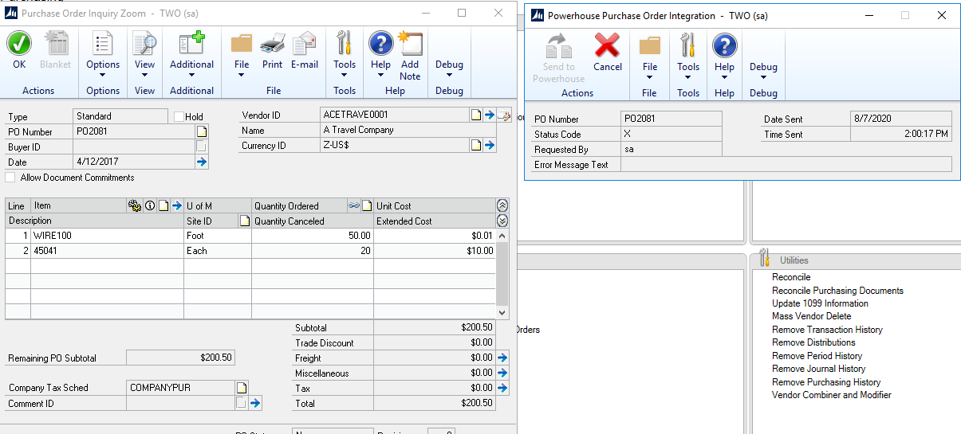
The Powerhouse Purchase Order Integration Window

Powerhouse SOP Transfer Integration Inquiry
Inquiry > Purchasing > Powerhouse PO Transfer Integration Inquiry
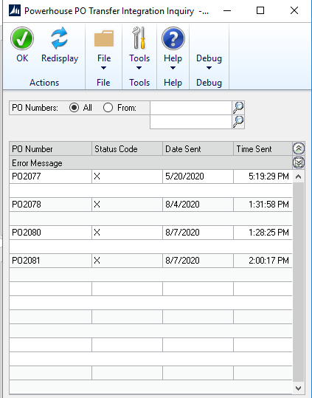
The Powerhouse PO Transfer Integration Inquiry Window

About Window

Version Information
This window contains information about the customizations’ current version

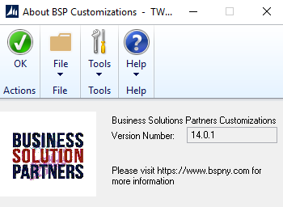
The BSP About Window

File Repository
All file releases would be stored in the GP2015 server. The exact location of the files is:
\\gp2015\GPShared\Software\BSP\BSP_CHK
The chunk file should be copied to the main Dynamics GP installation folder, while the files in the Addins folder should be copied to the Addins folder which is also inside the Dynamics GP installation folder.

Data Dictionary

BSP – Powerhouse Data Mapping

Sales Order
Header Fields
Powerhouse Field | Dynamics GP Field / Default Value
orderid | sopnumber
ordertype | documentid
custid | Customernumber + PrimaryShiptoAddressCode
custcode | customernumber
hostid2 | shippingmethod
poNum | customerponumber
dateordered | documentdate
dateorderspecified | TRUE
pickCompleteFlag | shipcomplete
bCompany | customername
shipByDate | Requestedshipdate
bAddress1 | BilltoAddress1
bAddress2 | BilltoAddress2
bAddress3 | BilltoAddress3
bCity | BilltoCity
bState | BilltoState
bZip | BilltoZip
bCountry | BilltoCountry or BilltoCountryCode
bPhone | BilltoPhone
bFax | BilltoFax
sAddress1 | ShipToAddress1
sAddress2 | ShipToAddress2
sAddress3 | ShipToAddress3
sCity | ShipToCity
sState | ShipToState
sZip | ShipToZip
sCountry | ShipToCountry
sPhone | ShipToPhone
sFax | ShipToFax
orCust1 | UserDefined1
orCust2 | UserDefined2
orCust3 | UserDefined3
orCust4 | UserDefined4
orCust5 | UserDefined5
orCust6 | UserDefinedDate1
orCust7 | UserDefinedDate2
orCust8 | UserDefinedTable1
orCust9 | UserDefinedTable2
orCust10 | UserDefinedTable3
orCust11 | PrimaryBillToAddressCode
orCust12 | PrimaryShipToAddressCode
orCust13 | TaxRegistrationNumber
orCust14 | TaxExempt1
orCust15 | TaxExempt2
orCust16 | Customer.Comment1
orCust17 | Customer.Comment2
orCust18 | Shippingmethod
orCust19 | Comment1
orCust20 | Comment2
orCust21 | Comment3
orCust22 | Comment4
orCust23 | Notes (SOP Document)
orCust24 | Notes (Comment Record)

Line Fields
Powerhouse Field | Dynamics GP Field / Default Value
hostline | lineitemsequence
hostid1 | componentsequence
itemid | itemnumber
custitemid | customeritem
orderline | lineitemsequence
orderlinespecified | TRUE
piecesOrdered | (Qty-QtyCancelled) * QtyInBaseUoM
piecesOrderedSpecified | TRUE
pickCompleteFlag | Order.SHipComplete
piecesToPick | either (orderqty or qtyallocated) * QtyInBaseUoM
piecesToPickSpecified | TRUE
price | unitprice / qtyinbaseUoM
priceSpecified | TRUE
olCust1 | Unitprice
olCust2 | Locationcode
olCust3 | Extendedprice
olCust4 | Commenttext
olCust5 | Uofm
olCust6 | Customeritemnumber
olCust7 | Customeritemdescription
olCust8 | Qtyallocated
olCust9 | Qtycancelled
olCust10 | Qtyinbaseuom
olCust11 | Customeritem.Userdefined1
olCust12 | CustomerItem.userdefined2
olCust13 | Customeritem.userdefined3
olCust14 | Customeritem.userdefined4
olCust15 | Customeritem.userdefined5
orderLineComments | Line.comments

Inventory
Item
Powerhouse Field | Dynamics GP Field / Default Value
ownerId | Owner field from Settings
itemId | ItemNumber
description | ItemDescription
itemClass | ItemClassCode
harmonizedCode | Category3
lotCtrlFlag | If ItemTrackingOption = 3 (True)
serialCtrlFlag | If ItemTrackingOption = 2 (True)
imCust1 | Category1
imCust4 | Category2
imCust5 | Category3
imCust6 | Category4
imCust7 | Category5
imCust8 | Category6
imCust9 | Alternate Item 1
imCust10 | Alternate Item 2
markForOsFlag | Y
hostTrackingFlag | Y
caseConveyFlag | N
autoLabelFlag | N

Receipt
Header Fields
Powerhouse Field | Dynamics GP Field / Default Value
warehouseId | Mapped location code
ownerId | Owner field from Settings
Po | ContainerID
releaseNum | 0
createdUsrID | User ID of Globals
createdDate | DateSent
receiptType | CONTR

Line Fields
Powerhouse Field | Dynamics GP Field / Default Value
warehouseId | Mapped location code
ownerId | Owner field from Settings
Po | ContainerID
releaseNum | 0
receiptLine | Computed Counter (multiples of 16384).
itemId | Item Number
usrUom | UofM
piecesOrdered | QTYShipped x U of M Qty in Base
piecesExpected | QTYShipped x U of M Qty in Base
vendorItemID | Vendor Item Number
glAccount | Inventory Account
hostLine | Receipt Line Item Sequence
dateExpected | Promised Date
rlCust1 | Receipt Number
rlCust2 | Location Code
rlCust3 | PO Number
rlCust4 | Item Description
rlCust5 | Vendor Item Number
rlCust6 | Vendor Item Description
rlCust7 | Actual Ship Date
rlCust8 | ShipMethod
rlCust10 | U of M Qty in Base

Purchase Order
Header Fields
Powerhouse Field | Dynamics GP Field / Default Value
warehouseId | Mapped location code
ownerId | Owner field from Settings
Po | Purchase Order Number
releaseNum | 0
createdUsrID | User ID of Globals
createdDate | DateSent
receiptType | CONTR
vendorId | Vendor ID
BCompany | Company Name
BAddress1 | Address 1
BAddress2 | Address 2
BAddress3 | Address 3
BCity | City
BState | State
BZip | Zip
BCountry | Country
BContact | Contact
BPhone | Phone 1
BFax | Fax
SCompany | Company Name
Address1 | Address 1
SAddress2 | Address 2
SAddress3 | Address 3
SCity | City
SState | State
SZip | Zip
SCountry | Country
SContact | Contact
SPhone | Phone 1
SFax | Fax
DateExpected | Promised Date

Line Fields
Powerhouse Field | Dynamics GP Field / Default Value
warehouseId | Mapped location code
ownerId | Owner field from Settings
Po | Purchase Order Number
releaseNum | 0
receiptLine | Ord field in PO Line table
itemId | Item Number
piecesOrdered | (QTY Ordered – Qty Canceled) x U of M Qty in Base
piecesExpected | QTY Remaining To Ship x U of M Qty in Base
vendorItemID | Vendor Item Number
glAccount | Inventory Account
hostLine | Ord field in PO Line table
dateExpected | Promised Date
Vendor id | Vendor ID
rlCust2 | Location Code
rlCust10 | U of M Qty in Base

Receiving (Powerhouse to GP)
Header Fields
Dynamics GP Field | Powerhouse Field/Default Value
POPRCTNM | ReceiptNumber
POPType | GPReceiptType.Shipment
ReceiptDate | activityDate or current date
BACHNUMB | Receiving ID prefix + Batch Frequency
VENDORID | vendorid

Line Fields
Dynamics GP Field | Powerhouse Field/Default Value
POPRCTNM | ReceiptNumber
POPType | GPReceiptType.Shipment
PONUMBER | poId
POLNENUM | host0
ITEMNMBR | itemId
VENDORID | vendorId
VNDITNUM | Host2
RCPTLNM | Host0
QTYSHPPD | Host1
InventoryAccount | glAccount

Lot Fields
Dynamics GP Field | Powerhouse Field/Default Value
POPRCTNM | ReceiptNumber
ITEMNMBR | itemId
SERLTNUM | lotId
SERLQTY | Pieces
RCTPLNM | Host0

Inventory Transfer (Powerhouse to GP)
Header Fields
Dynamics GP Field | Powerhouse Field/Default Value
IVDOCNBR | ifSeqNum
BACHNUMB | Receiving ID prefix + Batch Frequency
DOCDATE | activityDate or Current Date

Line Fields
Dynamics GP Field | Powerhouse Field/Default Value
IVDOCNBR | ifSeqNum
ITEMNMBR | itemId
TRXLOCTN | In Transfer Site (From Setup)
TRNSTLOC | In Transfer To Site (From Setup)
TRXQTY | Pieces
Reason_Code | hostAdjCode

Lot Fields
Dynamics GP Field | Powerhouse Field/Default Value
IVDOCNBR | ifSeqNum
ITEMNMBR | itemId
LOCNCODE | In Transfer To Site (From Setup)
SERLTQTY | Pieces
LOTNUMBR | lotId

BSP Tables

Table Name: BSP_Integration_SETP
Display Name: BSP Integration Setup
SQL ID: BSP_Powerhouse_SETP
Description: Contains the data for the GP – Powerhouse Integration Settings

Display Name | SQL Field | Data Type | Length
Company ID | CMPANYID | Int
User ID | USERID | Char | 15
BSP_PowerhousePassword | BSPPowerhousePassword | Char | 31
URL | URL | Char | 255
Owner | Owner | Char | 5
BSP_SOPBatchID | BSPSOPBatchID | Char | 15
BSP_SOPFulfillmentBatchID | BSPSOPFulfillmentBatchID | Char | 15
BSP_SOPProcessedBatch | BSPSOPProcessedBatch | Char | 15
BSP_SOPRejectedBatch | BSPSOPRejectedBatch | Char | 15
BSP_GPWS_URL | BSPGPWSURL | Char | 255
BSP_Frequency | BSPFrequency | Int
BSP_SOPLineQtyToUse | BSPSOLineQtyToUse | Smallint
BSP_EnableIVItemAutoSync | BSP_EnableIVItemAutoSync | TinyInt
BSP_PHPOReceivingType | BSPPHPOReceivingType | Char | 31
BSP_PHContainerReceivingType | BSPPHContReceivingType | Char | 31
BSP_BatchFrequency | BSPBatchFrequency | Smallint
BSP_RecvTrxBatchID | BSPRecvTrxBatchID | Char | 15
BSP_Rcv_InTransferSite | BSPRcvInTransferSite | Char | 11
BSP_Rcv_InTransferToSite | BSPRcvInTransferToSite | Char | 11

Table Name: BSP_Powerhouse_SO_Log
Display Name: BSP Powerhouse SO Transfer Log
SQL ID: BSP_Powerhouse_SO_Log
Description: Contains the sales order transfer information. Provides the users with information regarding status of the sales order transfer, date and time of transfer, as well as the error messages (if any).

Display Name | SQL Field | Data Type | Length | Notes
SOP Type | SOPTYPE | Smallint
SOP Number | SOPNUMBE | Char | 21
VersionNumber | VersionNumber | Char | 21
Date Sent | DATESENT | DateTime
Time Sent | TIMESENT | Datetime
Requested By | REQSTDBY | Char | 21
Status Code | STATUSCD | Char | 15 | X Success
Error Message Text | ERMSGTXT | Char | 255

Table Name: BSP_Powerhouse_SO_LNE_Transfer
Display Name: BSP Powerhouse SO Line Transfer
SQL ID: BSP_Powerhouse_SO_LNE
Description: Contains the sales order transfer item information. Provides the users with information regarding quantity information.

Display Name | SQL Field | Data Type | Length
SOP Type | SOPTYPE | Smallint
SOP Number | SOPNUMBE | Char | 21
Component Sequence | CMPNTSEQ | Int
Line Item Sequence | LNITMSEQ | Int
Item Number | ITEMNMBR | Char | 31
Version Number | VersionNumber | Char | 21
Requested Ship Date | REQSHIPDATE | DateTime
QTY | QUANTITY | Numeric | 19, 5
QTY Allocated | ATYALLOC | Numeric | 19, 5
QTY Prev Invoiced | QTYPRINV | Numeric | 19, 5
Date Sent | DATESENT | DateTime
Time Sent | TIMESENT | Datetime
Requested By | REQSTDBY | Char | 21

Table Name: BSP_Powerhouse_Item_Transfer
Display Name: BSP Powerhouse Item Transfer
SQL ID: BSP_Powerhouse_Item
Description: Contains the Inventory Item transfer information. Provides information on GP Inventory Items that were integrated to Powerhouse.

Display Name | SQL Field | Data Type | Length
Item Number | ITEMNMBR | Char | 31
Date Sent | DATESENT | DateTime
Time Sent | TIMESENT | DateTime
Requested By | REQSTDBY | Char | 21
Error Message Text | ERMSGTXT | Char | 255

Table Name: BSP_Powerhouse_Receiving_HDR
Display Name: BSP Powerhouse Receiving Header
SQL ID: BSP_Powerhouse_RCV_HDR
Description: Contains the container record transfer information. Provides the users with information regarding status of the container record transfer, date and time of transfer, as well as the error messages (if any).

Display Name | SQL Field | Data Type | Length
Container ID | BSPContainerID | Char | 31
Date Sent | DATESENT | DateTime
Time Sent | TIMESENT | DateTime
Requested By | REQSTDBY | Char | 21
Error Message Text | ERMSGTXT | Char | 255
Status Code | STATUSCD | Char | 15

Table Name: BSP_Powerhouse_Receiving_LINE
Display Name: BSP Powerhouse Receiving Transfer Line
SQL ID: BSP_Powerhouse_RCV_LINE
Description: Contains the Receipt Numbers that were included in the Container. It also contains Vendor information.

Display Name | SQL Field | Data Type | Length
Container ID | BSPContainerID | Char | 31
POP Receipt Number | POPRCTNM | Char | 17
Vendor ID | VENDORID | Char | 15
Vendor Name | VENDNAME | Char | 65
Vendor Document Number | VNDDOCNM | Char | 21

Table Name: BSP_Powerhouse_Receiving_Transfer
Display Name: BSP Powerhouse Receiving Transfer
SQL ID: BSP_Powerhouse_RCV_TRSFR
Description: Contains the Item Information per PO per Receipt that were included in the Container record that were sent to Powerhouse.

Display Name | SQL Field | Data Type | Length
Container ID | BSPContainerID | Char | 31
POP Receipt Number | POPRCTNM | Char | 17
PO Number | PONUMBER | Char | 17
Item Number | ITEMNMBR | Char | 31
Item Description | ITEMDESC | Char | 101
Vendor Item Number | VNDITNUM | Char | 31
Vendor Item Description | VNDITDSC | Char | 101
U of M Qty in Base | UMQTYINB | Numeric | 19, 5
Actual Ship | ACTLSHIP | DateTime
Promised Date | PRMDATE | DateTime
Quantity Shipped | QTYSHPPD | Numeric | 19, 5
U of M | UOFM | Char | 9
Location Code | LOCNCODE | Char | 11
Ship Method | SHIPMTHD | Char | 15
Requested By | REQSTBY | Char | 21
Date Sent | DATESENT | DateTime
Time Sent | TIMESENT | DateTime

Table Name: BSP_Powerhouse_PO_Transfer
Display Name: BSP Powerhouse PO Transfer
SQL ID: BSP_Powerhouse_PO
Description: Contains the Purchase Order transfer information. Provides information on GP Purchase Orders that were integrated to Powerhouse.

Display Name | SQL Field | Data Type | Length
PO Number | PONUMBER | Char | 17
Date Sent | DATESENT | DateTime
Time Sent | TIMESENT | DateTime
Requested By | REQSTDBY | Char | 21
Error Message Text | ERMSGTXT | Char | 255

Troubleshooting

If sales orders are not being pushed to Powerhouse, there are a couple of things you can check to verify if the service is running.
- Check if the Powerhouse Dynamics GP Integration Service is running. You can check this by navigating to Windows Start > Control Panel > Administrative Tools > Services. If the status is blank, right click on it and then select Start.

Powerhouse Dynamics GP Integration Service

- Verify that the GP Service and eConnect Services are running. Same as with the Powerhouse Dynamics GP Integration Service, navigate to Windows Start > Control Panel > Administrative Tools > Services. If the status is blank, right click on it and then select Start.

